Effective Thesis Writing

1

16-10-2021



Agenda

Q&A

Evaluation

Rubric

Tips & Tricks on

Formatting

Expectation

Setting of

remaining

chapter

Final Thesis

Structure

Quick Revisit on

Interim Report

Note:

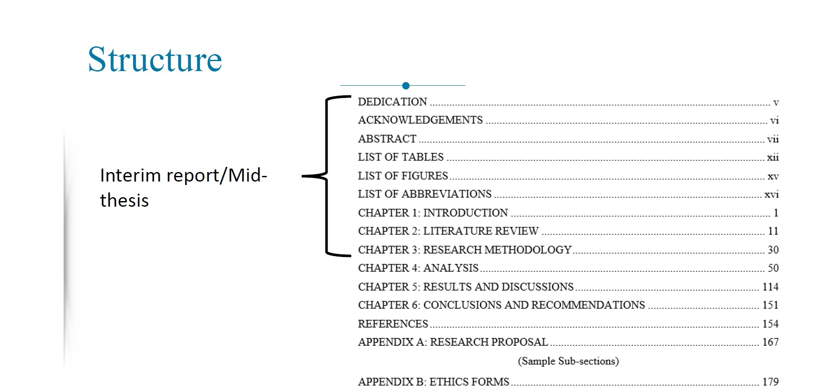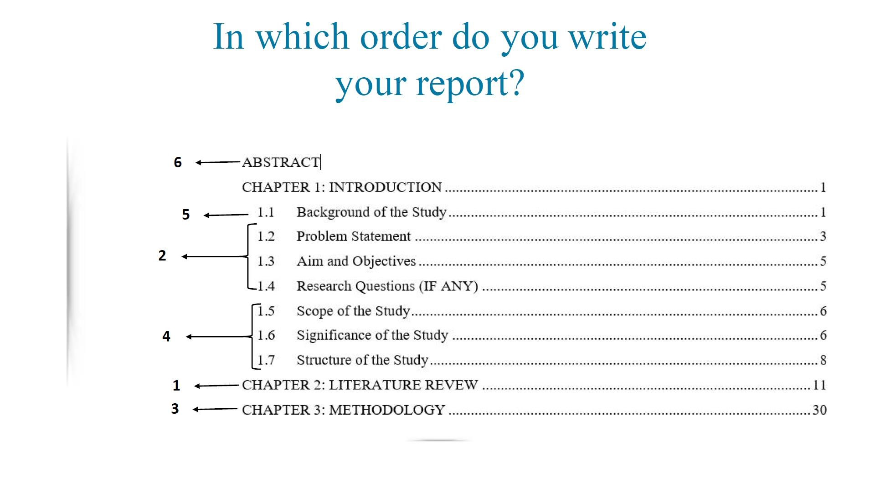

# Literature Review

Should cover the purpose of the study (The theme/research contextualization)

Should guide reader to understand the importance of your domain.

You need to answer What, Why and sometimes where

First show the forest(context) and then focus on the tree(specific areas)

Explore published thesis, scientific papers.(peer reviewed)

Avoid blogs and newspaper articles in systematic literature reviews

Look for Survey paper, if there is none. You have a good chance of publishing the same based on SLR. You can check out related survey papers instead.

Try to build a story line, talk about research gaps and challenges

Explore flowcharts and figures

Explain yourself: do not write something you are not confident about

Do not be too much basic, do not be so much perfectionist (maintain a balance)

You can screen papers by their abstract and if that entice you read conclusion/future recommendation as well

# Introduction

Theme of your research in brief

Set the context of the problem and hypothesis

A scenario with key information to understand meaning of your objectives (should build into motivation)

Highlight the gaps and how your research will contribute to these gaps

International and National implications

Introduction is not a literature review but its a glimpse of the total information

Last but not least present your general objective

# Introduction

|  |  |  |
| --- | --- | --- |
|  | |  | | --- | | * The main objective/purpose of the research * Specific objectives are expected to be around three listed in order of importance * Objective is not methodology! For achieving your objectives you may use one or more methods * Your methodology is based on your objective. Thus be careful while choosing them! | |

Setting your objective

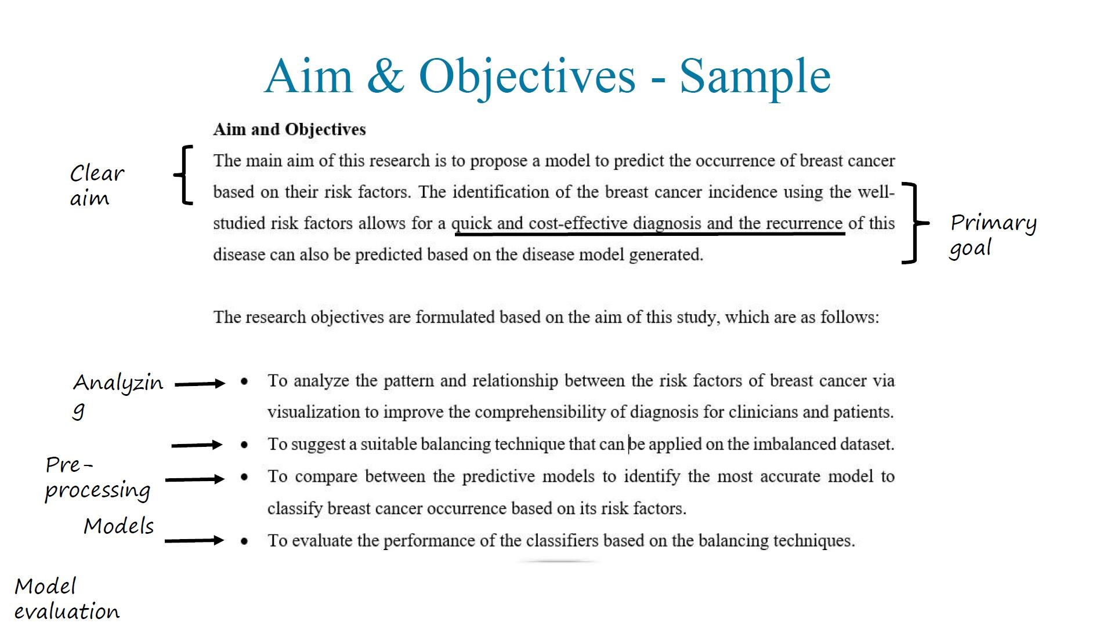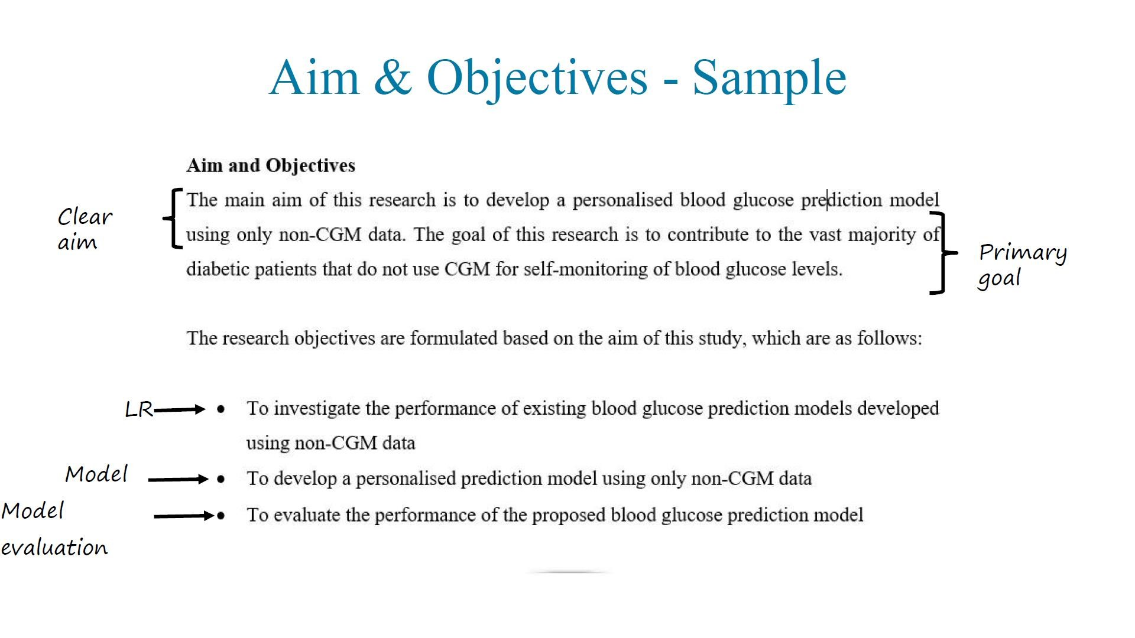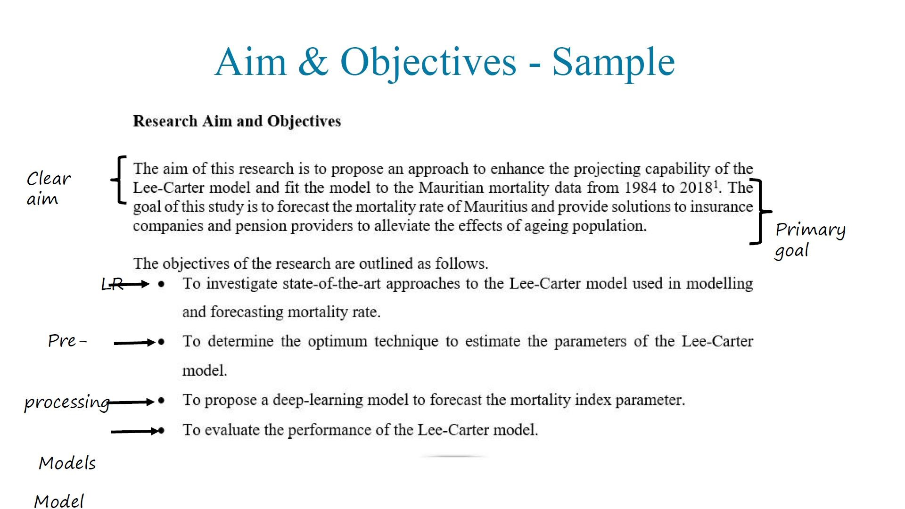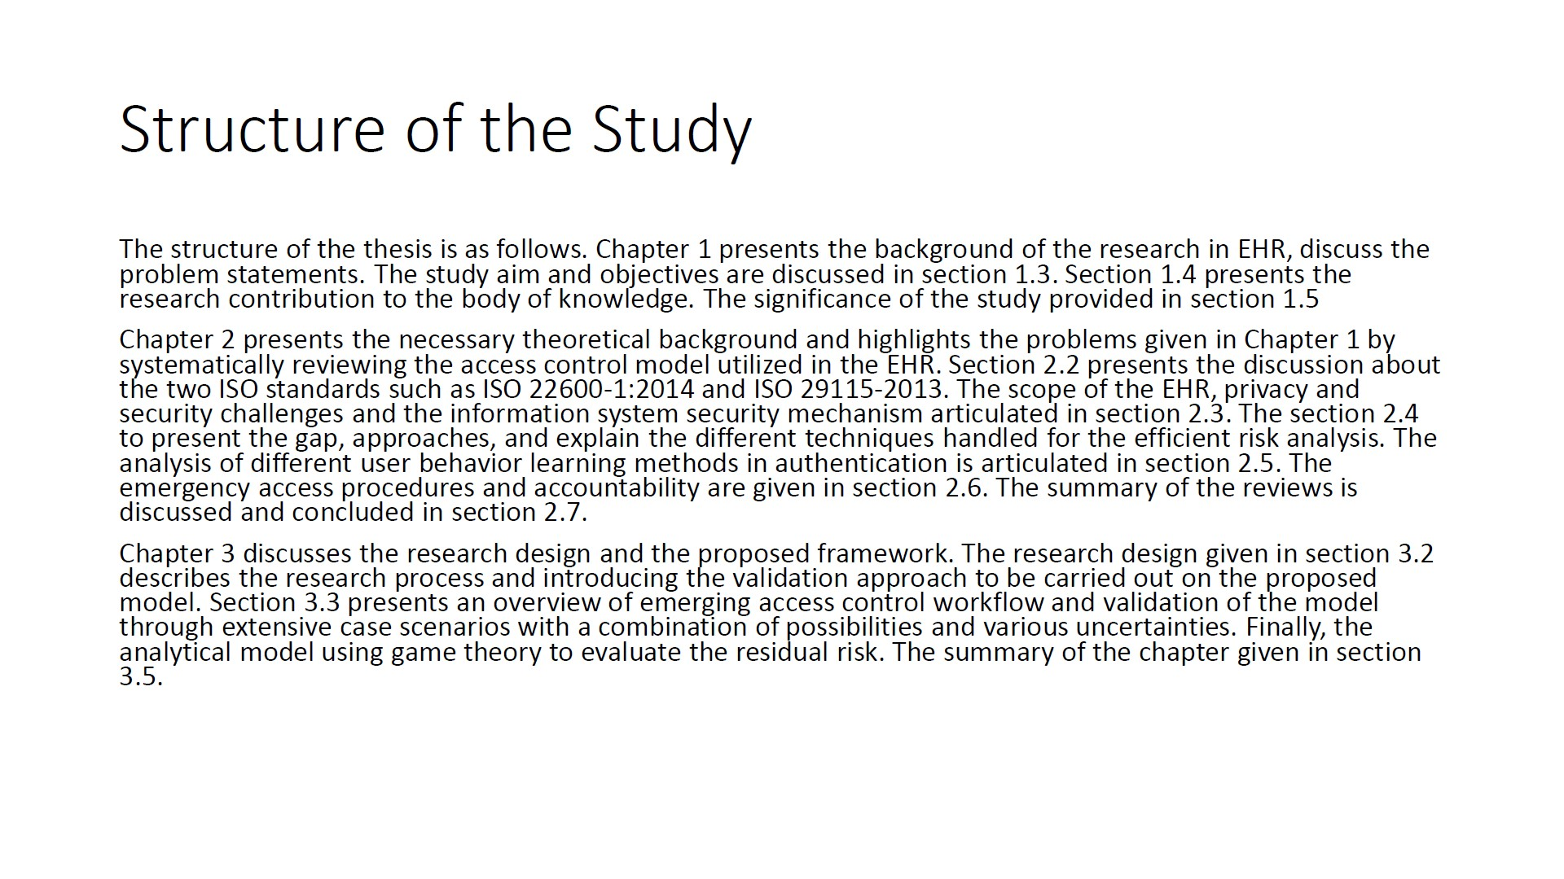

# Methodolgy

You need to address “HOW?”

Verb usage

Describe how will you address different objectives

Be consistent with the order of importance

For each method, cite the proper reference.

You can include following:

* Workflow
* Dataset Description
* Data Preprocessing
* Transformation/Augmentation
* Modelling Techniques
* Evaluation Metrics

For each objective there should be a method

# Chapter 3 Sample TOC

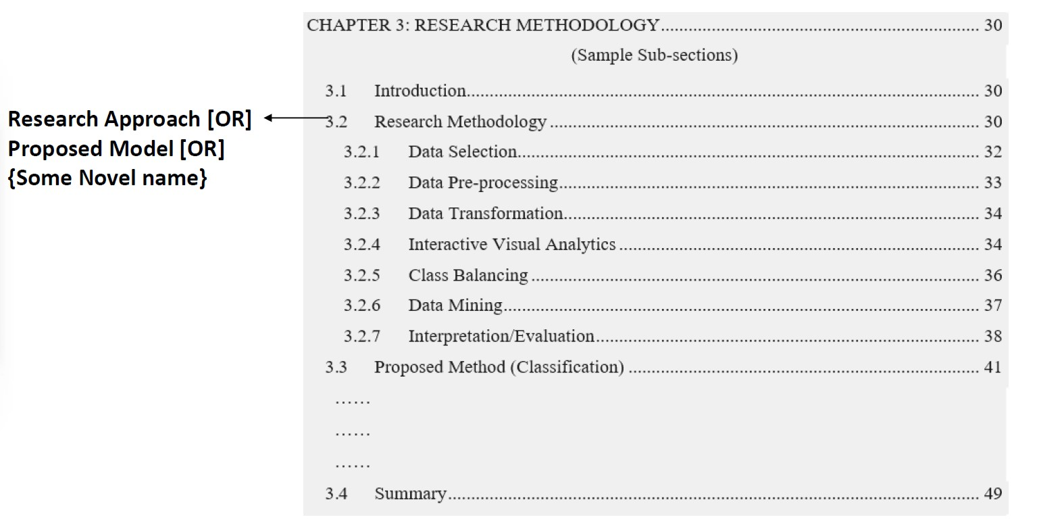

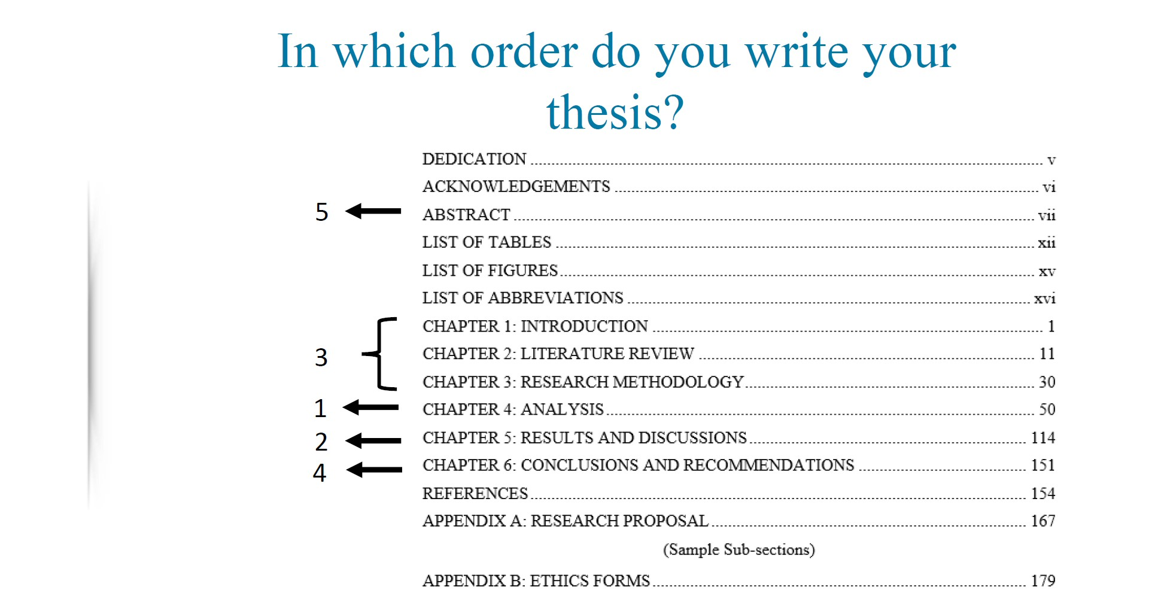

# Chapter 4 TOC Sample

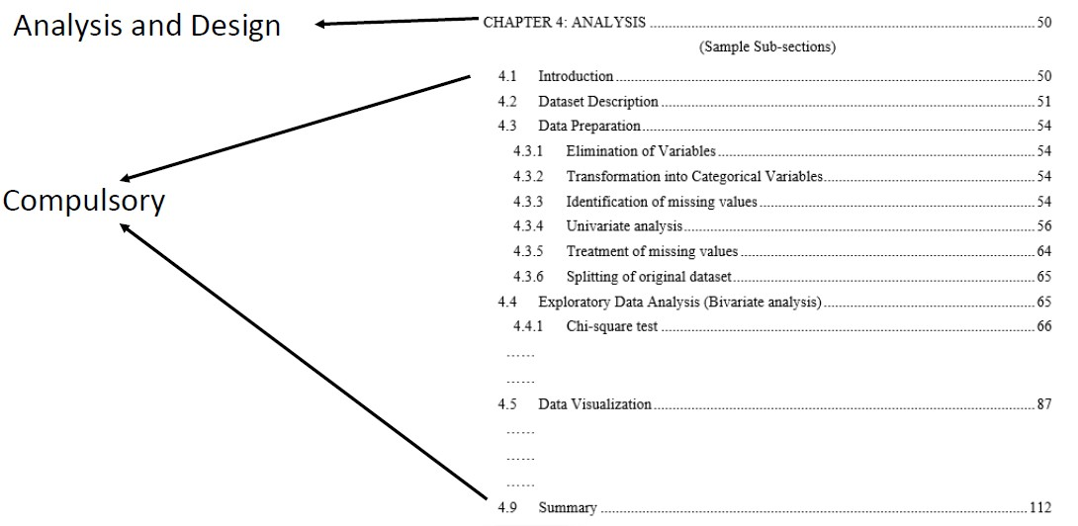

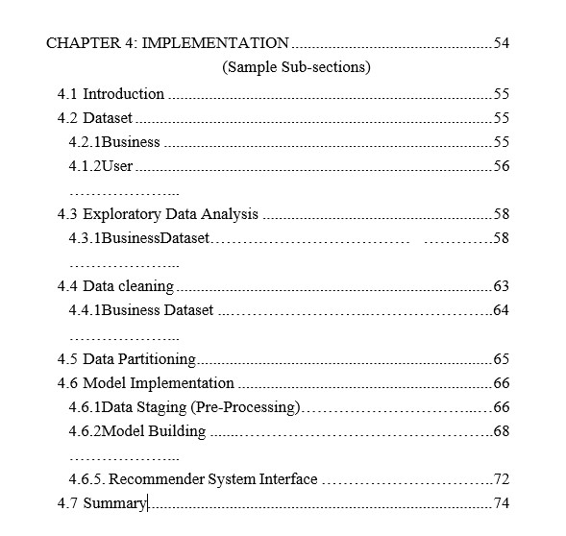

# Chapter 4 Analysis & Design/ Implementation

EDA

Hyperparameter tuning

Experiment Details

# Chapter 5 Sample TOC

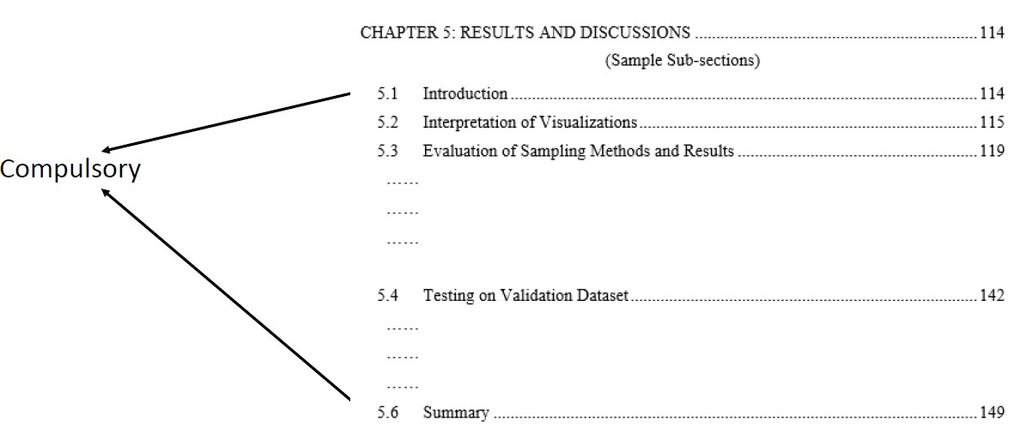

# Describing your Results

For each objective there should be a result. Answer each specific objective

Describe your results clearly and concisely

Do not be personal (I understand, I feel, I believe), or use people names. This is not scientific

Avoid pronouns, qualifiers and adverbs (extremely, possibly, of course, naturally, obviously, just), qualifying non qualifiable(unique, optimal, infinite)

Do not cite references unless it makes part of our objectives(comparison and discussion)

Be concise without being superficial, explore each result whether be positive or negative

Spell out numbers less than 10(except when used mathematically)

Tables, graphics and figures: only if they have a meaning. Refer them in text and do not repeat their captions in paragraphs

Clear legends, axis labels and line types

For flowcharts, you can use draw.io

Figure should be of good resolution

# Discussing your results

Approach your research in the context of current/past research

For each results you have finding in literature of the study from same dataset are they similar or different

Be critical: Do not copy paste ideas. Elaborate your own understanding

Explain possible differences in light of statistical significance, if applied

Find recent papers to discuss

Be careful with plagiarism

Set limitations of study and what did you do to minimize them

# Chapter 6 Sample TOC

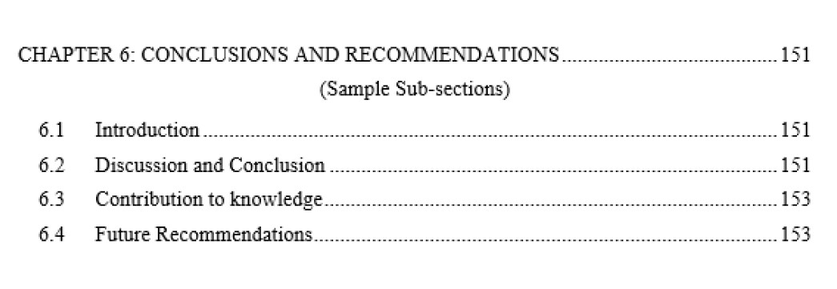

# Conclusion

Objective---->Method1---->Result---->Meaning---> Conclusion

Summarize the principal findings

Be organised

Do not include references/citation

Set the perspective: directions for future research

# Abstract

Project Proposal/Interim Report:

* Introduction
* Objectives
* Methodology
* Perspective’

Thesis

* Introduction
* Objective
* Methodology

•

Results

•

Conclusion

Read abstract from scientific abstracts(observe journal rules)

Do not use reference/citations or any graphic element in abstract

Be short, Concise and deep

24

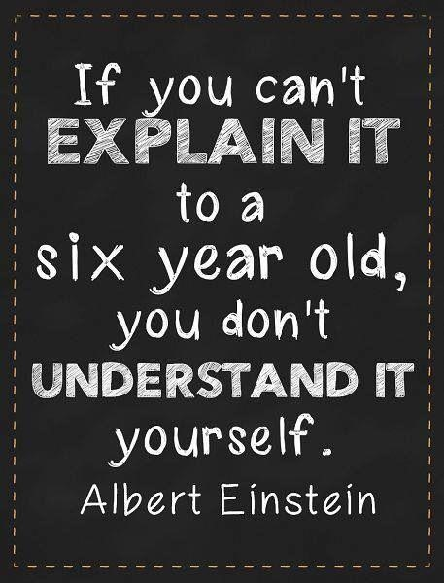

Read and Read more scientific articles

Few Tips!!!

Improve Vocabulary

Literature experience

Make records

Make notes

Writing with clarity

Avoid slangs and popular idiomatic expression

Use consistence tense

Be simple

Avoid too long sentence

Avoid very long paragraphs

Refer: Writing for computer Science by Justin Zobel

